ANN’S KETO CHILI RELLENO SOUP

1 pound 99% lean ground turkey breast

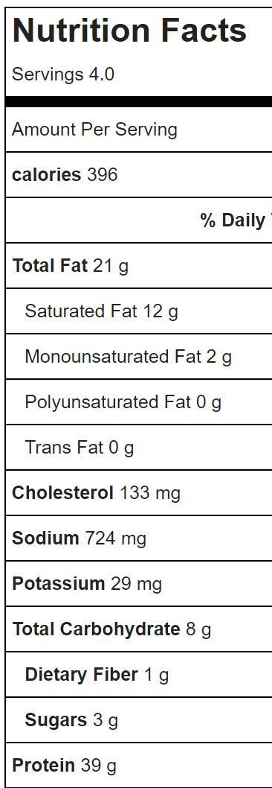

1/4 cup chopped green onion

1/2 teaspoon salt

1/4 teaspoon black pepper

1-1/2 teaspoon minced garlic

1 teaspoon ground cumin

1 teaspoon chili powder (I like Chipotle chili powder)

1/8 teaspoon cayenne pepper

4 ounce can diced green chilis

1/2 can (about 7 ounces) Fire-roasted diced tomatoes

4 cups beef or chicken broth

4 ounces cream cheese – chopped

5 ounces shredded cheddar cheese

1/4 cup chopped fresh cilantro (optional)

1/4 teaspoon xanthum gum (optional)

Add the turkey and all spices to a large saucepan, cooking over medium heat until meat is cooked through – about 5 minutes. Crumble the meat as you cook.

Add broth and simmer over medium heat for 15 minutes. Reduce heat to medium-low, stir in cream cheese, cheddar cheese and cilantro; continue to heat until melted. For a thicker consistency, add xanthum gum, but not necessary for taste. Stir in the xanthum gum and cook over a low boil 2-4 more minutes. It will thicken as it sets and cools, so don’t over do on the xanthum gum.

Serves 4

